Ref.No: AZ/1129/SAMIJF-SMG /FS/XI/2022
Kepada Yth:
PT. SAMIJF Mayong
Jl. Raya Jepara – Kudus Km 28, Ds. Sengonbugel
Kec. Mayong – Jepara

Up. Bapak Aditya

Semarang, 29 November 2022

Surat Permohonan Perpanjangan 2023

Dengan Hormat,
Sebelumnya kami mengucapkan terimakasih kepada management PT. SAMIJF MAYONG yang telah memberikan kepercayaan kepada kami Amazon dalam pelaksanaan Cleaning Service area SAMIJF Mayong.

Sehubungan dengan masa kontrak yang akan berakhir pada tanggal 31 Desember 2022, bersama ini kami memberanikan diri untuk mengajukan surat permohonan perpanjangan 2023 dengan mengacu UMK 2022 (Breakdown terlampir).

Besar harapan kami atas disetujui permohonan kami dan kami akan sangat bersyukur apabila Bapak serta Management SAMIJF Mayong dapat mengabulkan permohonan kami.

Apabila Bapak memerlukan informasi lebih detail, mohon untuk menghubungi kami di 024-8412753 atau 081-225577812 – 081666 1509 .

Terimakasih atas segala perhatian serta kepercayaan dari Bapak dan kami senantiasa menunggu kabar baik dari Bapak.

Hormat kami, Disetujui oleh,
PT. AMAZON PT. SAMIJF MAYONG
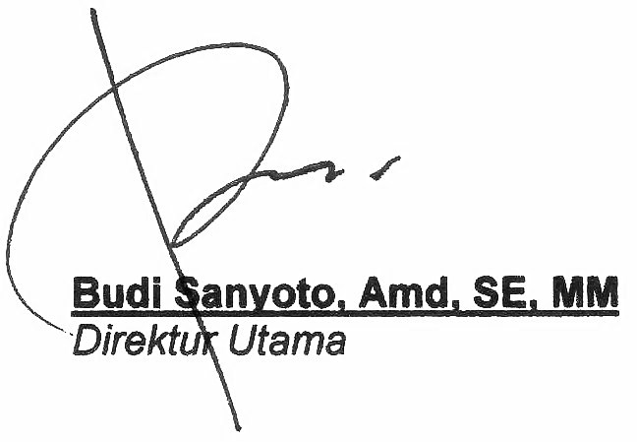

LAMPIRAN 1
Breakdown Outside
OUTSOURCING | EXPENSES | PER 1 EMPLOYEE | PERSON | TOTAL AMOUNT | REMARKS
A | Gaji Pokok | 2,108,403.11 | 1 | 2,108,403.11 | Upah
Cleaning | Jabatan | 450,000.00 | 1 | 450,000.00
( Spv ) | Insentif | 150,000.00 | 1 | 150,000.00
 | THR = (upah + jabatan)/ 12 bulan | 213,200.26 | 1 | 213,200.26
 | BPJS Ketenagakerjaan 6.24% | 131,564.35 | 1 | 131,564.35
 | BPJS Kesehatan 4% X upah | 84,336.12 | 1 | 84,336.12
 | Over Time | 0.00 | 1 | 0.00 | Ditagihkan
 | Komponsasi Akhir Kontrak | 175,700.26 | 1 | 175,700.26
Total I |  | 3,313,204.11 |  | 3,313,204.11
 | Training & Coordination | 10,000.00 | 1 | 10,000.00
 | Chemical & Consumable | 0.00 | 1 | 0.00
 | Peralatan | 0.00 | 1 | 0.00
 | Machinerry | 0.00 | 1 | 0.00
 | Uniform | 20,000.00 | 1 | 20,000.00 | 2 Stel
 | Management Fee | 265,056.33 | 1 | 265,056.33
TOTAL A |  | 3,608,260.44 | 1 | 3,608,260.44
B | Gaji Pokok | 2,108,403.11 | 1 | 2,108,403.11 | Upah
Cleaning | Jabatan | 250,000.00 | 1 | 250,000.00
(TL) | Insentif | 100,000.00 | 1 | 100,000.00
 | THR = (upah + jabatan)/ 12 bulan | 196,533.59 | 1 | 196,533.59
 | BPJS Ketenagakerjaan 6.24% | 131,564.35 | 1 | 131,564.35
 | BPJS Kesehatan 4% X upah | 84,336.12 | 1 | 84,336.12
 | Over Time | 0.00 | 1 | 0.00 | Ditagihkan
 | Komponsasi Akhir Kontrak | 175,700.26 | 1 | 175,700.26
Total I |  | 3,046,537.44 |  | 3,046,537.44
 | Training & Coordination | 10,000.00 | 1 | 10,000.00
 | Chemical & Consumable | 60,000.00 | 1 | 60,000.00
 | Peralatan | 45,000.00 | 1 | 45,000.00
 | Machinerry | 30,000.00 | 1 | 30,000.00
 | Uniform | 20,000.00 | 1 | 20,000.00 | 2 Stel
 | Management Fee | 243,723.00 | 1 | 243,723.00
TOTAL B |  | 3,455,260.44 | 1 | 3,455,260.44
C | Gaji Pokok | 2,108,403.11 | 23 | 48,493,271.53 | Upah
Cleaning OS | Jabatan | 0.00 | 23 | 0.00
& PRD | Insentif | 0.00 | 23 | 0.00
( Member ) | THR = (upah + jabatan)/ 12 bulan | 175,700.26 | 23 | 4,041,105.96
 | BPJS Ketenagakerjaan 6.24% | 131,564.35 | 23 | 3,025,980.14
 | BPJS Kesehatan 4% X upah | 84,336.12 | 23 | 1,939,730.86
 | Over Time | 0.00 | 23 | 0.00 | Ditagihkan
 | Komponsasi Akhir Kontrak | 175,700.26 | 23 | 4,041,105.96
Total I |  | 2,675,704.11 |  | 61,541,194.46
 | Training & Coordination | 10,000.00 | 23 | 230,000.00
 | Chemical & Consumable | 60,000.00 | 23 | 1,380,000.00
 | Peralatan | 45,000.00 | 23 | 1,035,000.00
 | Machinerry | 30,000.00 | 23 | 690,000.00
 | Uniform | 20,000.00 | 23 | 460,000.00 | 2 Stel
 | Management Fee | 214,056.33 | 23 | 4,923,295.56
TOTAL C |  | 3,054,760.44 | 23 | 70,259,490.01
GRANDTOTAL ( A + B + C ) |  |  | 25 | 77,323,010.88 | Exclude PPN

Noted : - Harga belum termasuk PPN
- Harga mengacu UMK 2022. Jika ada SK Gubernur mengenai kenaikan UMK 2023, harga akan ditinjau kembali
- Lembur / Overtime atas persetujuan User ditagihkan

LAMPIRAN 2
BREAKDOWN INSIDE
OUTSOURCING | EXPENSES | PER 1 EMPLOYEE | PERSON | TOTAL AMOUNT | REMARKS
A | Gaji Pokok | 2,108,403.11 | 1 | 2,108,403.11 | Upah
Cleaning | Jabatan | 250,000.00 | 1 | 250,000.00
( Spv ) | Insentif | 100,000.00 | 1 | 100,000.00
 | THR = (upah + jabatan)/ 12 bulan | 196,533.59 | 1 | 196,533.59
 | BPJS Ketenagakerjaan 6.24% | 131,564.35 | 1 | 131,564.35
 | BPJS Kesehatan 4% X upah | 84,336.12 | 1 | 84,336.12
 | Over Time | 0.00 | 1 | 0.00 | Ditagihkan
 | Komponsasi Akhir Kontrak | 175,700.26 | 1 | 175,700.26
Total I |  | 3,046,537.44 |  | 3,046,537.44
 | Training & Coordination | 10,000.00 | 1 | 10,000.00
 | Chemical & Consumable | 0.00 | 1 | 0.00
 | Peralatan | 0.00 | 1 | 0.00
 | Machinerry | 0.00 | 1 | 0.00
 | Uniform | 20,000.00 | 1 | 20,000.00 | 2 Stel
 | Management Fee | 243,723.00 | 1 | 243,723.00
TOTAL A |  | 3,320,260.44 | 1 | 3,320,260.44
B | Gaji Pokok | 2,108,403.11 | 5 | 10,542,015.55 | Upah
Cleaning Office | Jabatan | 0.00 | 5 | 0.00
( Member ) | Insentif | 20,000.00 | 5 | 100,000.00
 | THR = (upah + jabatan)/ 12 bulan | 175,700.26 | 5 | 878,501.30
 | BPJS Ketenagakerjaan 6.24% | 131,564.35 | 5 | 657,821.77
 | BPJS Kesehatan 4% X upah | 84,336.12 | 5 | 421,680.62
 | Over Time | 0.00 | 5 | 0.00 | Ditagihkan
 | Komponsasi Akhir Kontrak | 175,700.26 | 5 | 878,501.30
Total I |  | 2,695,704.11 |  | 13,478,520.53
 | Training & Coordination | 10,000.00 | 5 | 50,000.00
 | Chemical & Consumable | 95,000.00 | 5 | 475,000.00
 | Peralatan | 100,000.00 | 5 | 500,000.00
 | Machinerry | 90,000.00 | 5 | 450,000.00
 | Uniform | 20,000.00 | 5 | 100,000.00 | 2 Stel
 | Management Fee | 215,656.33 | 5 | 1,078,281.64
TOTAL B |  | 3,226,360.44 | 5 | 16,131,802.18
GRANDTOTAL ( A + B + C + D ) |  |  | 6 | 19,452,062.61 | Exclude PPN

Noted : - Harga belum termasuk PPN
- Harga mengacu UMK 2022. Jika ada SK Gubernur mengenai kenaikan UMK 2023, harga akan ditinjau kembali
- Lembur / Overtime atas persetujuan User ditagihkan

